Product learning from building a reuse marketplace app.

(Key learning from building and marketing digital product - for NFP startups and CTO)

Executive Summary

While creating and marketing a social mobile app has best intentions, it has a vast amount of constraints. In order to achieve success (measured usually by number of people benefitting from the app), one needs persistent efforts in delivering, marketing, collaboration with people on social channels and / or with other similar organisations.

This paper summarises why we built a mobile reuse app, how we planned and delivered the product, what we tried across stakeholder engagement, marketing, and legal setup, and why we are still struggling with adoption. It concludes with key learnings and what we would do differently if we were to attempt a similar civic marketplace again.

The Original Hypothesis
Our initial hypothesis was if we could make items placed on curbside across the country in near real time, we could contribute to:
- Reduced collection efforts from council.
- Minimise landfill and factory recycling, and
- Having people get free re-usable items
Publicly available dataset indicated increasing rate of curbside collections in Victoria and other states. As a result, council collection costs and effort increase along with environmental damage due to increased landfills and factory recycling.
Besides, reusable items do not get a second chance. It creates economic pressure on people who could make use of these items instead of buying new ones. This especially true for people recently migrated to the country, students, and anyone else who practices circular economy.
Therefore, a “near real-time” visibility of these items made complete sense. A mobile app felt like a reasonable intervention since nearly all of us own a smart mobile phone with internet connection. This can be used to post any specific set of items from curbside by anyone passing by.

What we built

MVP (late 2020) and what “done” meant
Our MVP efforts can be summarized in the following sections:
- End Goal: Provide a simplest possible, with seamless experience, all familiar, a purpose driven user interface with an aggressive target of onboarding 1000 users in 3 months.
- Brainstorm on MVP features: Focused on absolute minimum functionality to drive the purpose which translates to creating an interface with no login or user verification and user directly navigating to the items recently posted and a way to post new items.
- Functionality Development: We selected low-cost serverless approach since it was easy to use, low cost, familiar enough to get started with.
- FrontEnd development: Once we have functionality ready and tested, it needs to be hooked with user interface. Since we lacked skills on front end side of the app, we had to hire a freelancer from Upwork with a limited budget and funds available. It took a while to hire a good freelancer and a fair bit of to and fro before the interface was created as per our intended design. The language choice was react-native since it could translate to native within either iOS or Android platforms.

Ask for funding, Creation of NFP Entity (2021) and Publishing App
- Marketing and presentation for funding: With a bunch of items in our product roadmap, including marketing and legal efforts, we needed funding. We approached 4 different councils and presented our MVP product, roadmap and how it can benefit the council and community over zoom calls. All except one council were risk-focused and cautious. We got AUD 10k grant from that council which was a big morale boost. We later applied at 3 more different grants (From private and public entities) which were not positive. The 10k funding helped us in legal, marketing, roadmap items development, app publishing and ongoing operational costs.
- Legal: We hired lawyer to create an org structure for NFP and register our NFP business.
- Publishing: We created developer accounts within the 2 widely used mobile platforms and with a few hiccups we were able to push and publish our apps for consumption.

2021–2023 improvements: login, maps, notifications
- With no traction and feedback from our close friends and family, we decided to build a few interesting items from our roadmap that can potentially get visibility and drive downloads. First we decided to build a login functionality only to verify a (human) user since the data was not private. It was an entirely B2C model with no restrictions on read and search functionality. For the compliance, safety and moderation purposes only we tracked phone number and user’s (random) ID from our engine.
- Once that’s successfully implemented, we integrated Google map in the app to show our users items location within a map.
- We also made use of Google’s Firebase to broadcast notifications if any users post an item. The notification was customizable with a toggle button allowing user to turn it off / on on-demand.

Go-to-market experiments (what we tried)
- Thanks to the council grant, we were also able to get credits for Google Ads and hired another set of freelancers for conversion to downloads. However, unfortunately, due to Google’s limitations on their offerings, only the org website clicks could be tracked and no way to put the ads in the app marketplace.
- Flyers: We also got the subscription from Canva which we used to design and create flyers. We ordered printouts with different sizes to put them into community libraries, college campuses, and on street manual distribution.
- Volunteer seeding: We tried 2 different waves of hiring volunteers to seed posts for general consumptions. However, this also went nowhere with apparently no interest from volunteer community. We also tried registering the company with various volunteering organizations for support but still got no visibility.
- Meetups / Webinar and council outreaches: I tried to talk about it in meetups and asked for presentation (with no response), conducted a webinar (well received but no conversion to downloads), and kept reaching out to councils with email requests.

Our Observations:
- Installs: Except for a few close friends and family members, installations were only in single digit / handful. These instances of installs seem to be aligned with any events such as addressing / briefing volunteer groups or a strong LinkedIn post.
- Supply: Even though we tried to seed with various volunteer waves, more than 95% of the posts were done either by me or other co-founder.
- Engagement: Unfortunately, there was no visibility on install / uninstall of the app due to technical constraints.
- Funnel Reality: While majority are aware of the underlying problem discussed above and appreciate the importance of our app, their words have not translated into actions (i.e. install and retention with active usage) so far.

Why did it not scale
- Cold starts with limited liquidity: We boot-strapped ourselves with limited amount that we could afford at the time. This created pressure directly on us, putting additional time and effort into building backend engines while also looking for a cheap but still a decent freelancer for frontend user experience layer. This was hectic since there were numerous to-and-fros with the freelancer and time difference, along with misalignment on the requirements added more complexity in collaboration.
- Lack of incentives for posts: Partly due to limited fund availability, we were unable to incentivize posts / uploads.
- Trust and logistics: The use case for our app was limited to the items specifically kept on the curbside and hence there was no ownership of the items posted. There was no in-app claiming workflow but we relied on comments to confirm items (or a subset of) were taken.
- Lack of marketing support for NFP: While one of the councils thankfully agreed for the funding, it (and others) was not ready to market the product even though this is likely benefit them.
- Comparison with other marketplaces: Perhaps not strong enough.
- Funding constraints: We could experiment with product, users, marketing, reach outs via different paid social channels but we seriously lacked funding that held us back.

What we’d do differently
- Start hyper-local (one campus/suburb): Pick a suburb or 2 which have the highest rate of items in the curbside and use our own downloaded app to post items, and demo door to door.
- Partner-first distribution (property managers, student unions, movers, hard rubbish days): Target audience to be collaborated closely with from the get-go, get their requirements, and show them the prototypes and MVP.
- Incentives for supply (posting) before demand (browsing): While volunteers may help, it always is a safe bet to incentivize the effort (with gift cards, or with monetary incentives).
- Loop marketing with continuous growth: A possible way to fail fast could have been a clear reinforced continuous cycle that clearly shows that the app / effort could sustain itself such as acquire and retain x users within y days/months so that monetization through either targeted advertisements and/or using the app can be achieved that in turn, will allow additional acquisition efforts.

Key Learnings

Cold start is a liquidity design problem
A reuse marketplace is a two-sided system. Until there is enough supply density (in a tightly bounded area), downloads won’t happen, regardless of awareness. In our case, even with ~200–1000 posts at peak, the supply (of posts) wasn’t organically crowd-sourced. These posts were seeded / generated by us at random, which didn’t create a sustainable loop.

Incentives matter, but they must be structured
Volunteers alone are unreliable for supplying into the system. If posting is an effort (For which volnteers were hired), early supply needs deliberate incentives (gift cards, partner rewards, community credits) and clear rules. The key is to start small and prove that incentives improve posting frequency and downstream engagement (i.e. downloads) before scaling spend.

Trust + logistics is the hidden tax in “free stuff”
Without a claiming mechanism and without ownership verification, you end up relying on comments to know whether an item still exists or its condition is accurate. That uncertainty results in low to no converstions i.e. retention / downloads since the users will not like “wasted trips” to the location. Trust, safety, and logistics need to be product features, but in our case (For right or wrong reasons), it was one of the biggest assumptions.

Councils can fund innovation, but they rarely drive distribution
A grant helps morale and runway, but councils often operate with legal and risk constraints and may avoid active promotion. Treat councils as enablers (policy support, visibility through official channels, access to hard-rubbish calendars, venues for pilot events), not as a promotional / marketing channel.

Offline awareness doesn’t equal installs distribution must be “embedded”
Flyers, libraries, word of mouth, and campuses create awareness, but app installs usually require an embedded moment: an event, a partner workflow, or a direct trigger (e.g., “Hard rubbish week - scan here, claim now, pickup window tonight” or finding out “garage sale” events at specific locations and put a QR code at the signage). If there is no urgency, the interest (which seem to be a “great idea” during a quick demo), becomes passive.

Build decisions were not aligned with adoption loops
We shipped an MVP and continued iterating (login, map view, notifications) based on feedback, but feature improvements don’t solve missing market loops. Product work must be directly tied to a measurable loop: post → discover → collect → confirm taken → repeat/referral.

Measurement is a must (even for NFP pilots)
We lacked end-to-end visibility on install/uninstall and retention, which limited our ability to diagnose where the funnel broke. For any future attempt, analytics needs to be part of MVP definition: installs, activation, retention, and “successful collection” confirmation.

If you can’t fund experiments, you must constrain scope aggressively
Funding constraints limited paid channels and incentives. The practical alternative is to go hyper-local, partner-first, and run short experiment cycles with hard success criteria (e.g., X active listers and Y weekly collections in a single suburb/campus) before expanding.

Be consistent in your messaging across channels
While we put efforts documenting and putting the pack together with peer reviews, we could have had the messaging reviewed with a more experienced professional in our circle esp the ones in the leadership / sales marketing positions. The feedback helps refining the messaging and make it more succinct aligned with the audience and delivery timing.

Proud Achievements
While we are unable to scale so far, there are outcomes that made us proud:

Idea to product
When we started brainstorming the idea, with constraints on funding and time (due to our full-time obligations), we were not sure whether we can get a product ready and delivered within a year. However, we just decided to give our best shot for a year, rolled our sleeves, and not only designed & developed end-to-end solution, but also demonstrated people skills by collaborating with legal, councils, freelancers, vendors. We shipped, iterated, and kept going.

Creation of legal entity and running it
We decided to publish and market the product (The app) under a legal Not for Profit entity. We studied requirements for creating and registering the entity, hired a lawyer, and created a website. Till date, we have been responsibly running the entity.

Securing external validation and funding
While we pitched this solution to multiple councils, we secured the grant of AUD 10k from one of the councils, proving that the problem resonates with at least one decision-maker.

Navigating real-world constraints
Reality hit our face when we realized marketing limitations, waves of volunteer recruitment, and how stakeholders defend status-quo. We learned how product outcome and features are shaped by these constraints.

Re-usable framework
The learnings hopefully translate into a reusable framework for other social enterprise initiatives.

Conclusion and Next Steps
The app (Known as “Dumpick”) is still available to download on both Android and iOS platforms (https://mrkloudfoundation.org/dumpick : If you want to know more). While we started the project with good intentions and with awareness of the known problem, we were not able to onboard enough users to initiate a “self-funded” model for this initiative to support itself.

Appendix A
A1) System overview (high level)
Goal: low-cost, low-ops, fast iteration, suitable for early-stage adoption experiments.
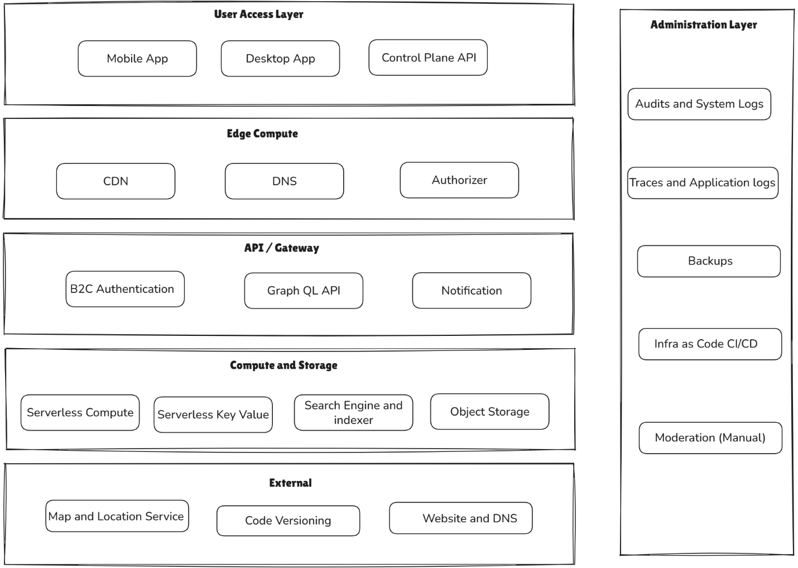
A2) Architecture diagram (general)
Boxes + arrows:
- Client (Mobile UI) → API (GraphQL)
- API → Auth (optional) / Business logic
- Business logic → DB + Storage + Notifications
- Admin tooling → API
- Monitoring around everything
If you want, I can generate a clean diagram later (PNG/SVG).
A3) Key architectural decisions (decision log)
Write as: Decision → Why → Trade-off
Examples aligned to your build:
- Serverless-first for cost + speed; trade-off: local testing complexity.
- GraphQL for flexible mobile queries; trade-off: extra schema discipline and client/server coupling.
- No-login MVP to reduce friction; trade-off: spam/moderation risk.
- Add login later for moderation; trade-off: onboarding friction.
- Map view for discovery; trade-off: location precision + privacy considerations.
- Push notifications for re-engagement; trade-off: requires careful opt-in UX.
- Minimal PII (phone/ID only) for safety/moderation; trade-off: limited trust signals.
- Image upload pipeline to keep client light; trade-off: storage + moderation needs.
A4) Testing approach + Java desktop tool
Explain the intent:
- Built a desktop harness to simulate client calls and validate API behaviour quickly (especially GraphQL request/response and workflows).
- Helped regression-test common flows: create post, fetch latest, query by area, update status, etc.
Then add a note for GitHub:
- “This tool is published in a sanitised form for learning and demonstration.”

